

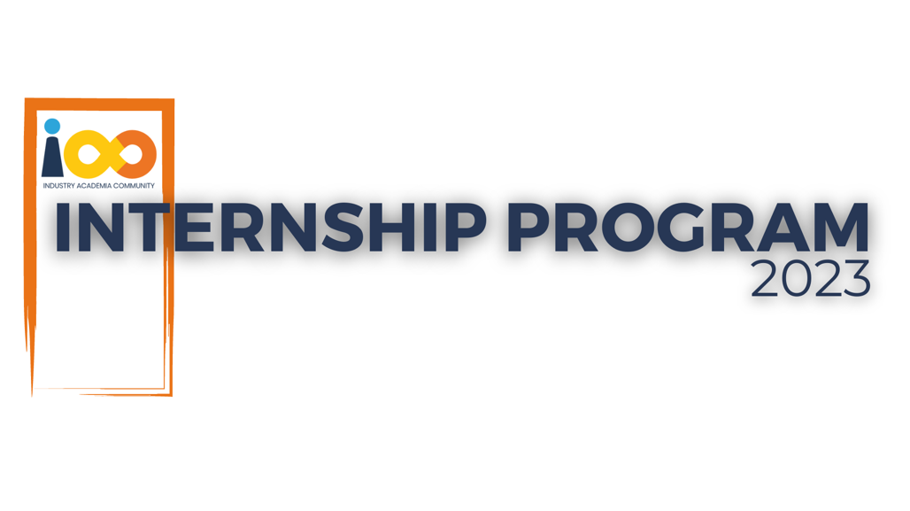

Page left blank intentionally

**INDEX**

**1** **PROJECT DETAILS** 2

**2** **SUMMARY** 2

**3** **INTRODUCTION** 2

3.1 Background 2

3.2 Stakeholders 2

3.3 Objectives 2

**4** **METHODOLOGY** 2

4.1 Considerations & Assumption 3

4.2 Approach 3

4.3 Activities 3

**5** **TARGETTED V/S ACHIEVED OUTPUT** 3

**6** **CONCLUSION** 3

**7** **APPENDICES** 4

7.1 Appendix A – Title 4

**General Instructions for using the Live Project Report Template**

* This template and the subsequent document created using this template is a confidential document and is the intellectual property of Cloud Counselage Pvt. Ltd. Circulating it outside of the organisation without the consent of Cloud Counselage Pvt. Ltd. is the breach of company policies and will lead to legal actions
* This template is a guideline document to communicate the implementation of design ideas and the results of the work to the stakeholders.
* The **text between inequality (< >) is to be replaced** by relevant text
* Please **remove the yellow highlight on the Text** between the inequality (< >). This is done to help you notice the text to be changed/replaced
* The text in *italics* highlighted in grey is just for reference and should be removed after adding the relevant text

# **PROJECT DETAILS**

|  |  |  |  |
| --- | --- | --- | --- |
| **Project Name** | Data Analyst | | |
| **Project Sponsor** | Tushar Topale | | |
| **Project Manager** | Harshada Topale | | |
| **Start Date** | DD-MMM-YYYY | **Completion Date** |  |

# **SUMMARY**

The Student Data Analysis project aimed to perform a thorough and in-depth analysis of student-related data. This dataset, provided for analysis, consisted of diverse features covering academic, demographic, social, and professional dimensions of students. With the increasing reliance on data in shaping education systems, recruitment practices, and event management strategies, such a project is pivotal in deriving patterns and correlations that may otherwise go unnoticed. The initiative serves multiple purposes, such as identifying strengths and weaknesses in academic performance, correlating student backgrounds to their educational outcomes, and understanding preferences and behaviors in extracurricular activities.

The motivation behind the project lies in the necessity for stakeholders—students, academic institutions, and corporate recruiters—to better understand how various factors such as GPA, income level, city of origin, and technical skills (e.g., Python experience) affect student expectations and performance. A significant aspect of the analysis was focused on expected salaries and how they relate to other measurable traits. For instance, determining whether leadership roles during college, proficiency in programming languages, or involvement in events can predict future income expectations.

In the long term, the project is expected to guide curriculum developers in tailoring educational programs that align with student aspirations and market trends. It will help institutions personalize learning plans and career guidance strategies, improve student participation in events, and enable recruiters to identify high-potential candidates early in their academic journey. Furthermore, this analysis provides a framework for integrating multiple datasets, setting the stage for more advanced analytics like predictive modeling and automated career guidance systems. By interpreting and visualizing the relationships among different data variables, stakeholders can make informed, evidence-based decisions.

# **INTRODUCTION**

## Background

As the world increasingly moves toward data-centric decision-making, the education sector is no exception. The digitization of student records, event registrations, and skill assessments has generated large amounts of data, but without proper analysis, this data remains untapped. Educational institutions, career counselors, and recruiters can leverage these datasets to derive meaningful patterns. This project was initiated to explore a dataset composed of student attributes, ranging from personal details and academic performance to technical expertise and event participation.

Analyzing such data holds immense value: it can highlight disparities, detect high-performing individuals, identify trends in city-wise student enrollment, and predict future outcomes like salaries or graduation timelines. In today’s competitive and highly dynamic education environment, such data-driven insights can be pivotal. Institutions can optimize their strategies for resource allocation, curriculum development, and industry collaboration. Students, on the other hand, can become more self-aware and align their goals with real-world expectations. This background formed the foundation for the comprehensive analysis undertaken in this project.

## Stakeholders

The analysis performed during this project caters to a wide array of stakeholders. Each of these entities stands to benefit from the insights derived from student data:

* **Students**: Can assess their standing and areas for improvement
* **Educational Institutions**: Use insights for designing academic interventions and tracking performance
* **Event Organizers**: Can understand participation trends and tailor events accordingly
* **Recruiters and Companies**: Can identify potential candidates with desired qualifications and skills
* **Cloud Counselage Pvt. Ltd.**: Gains value through the improved accuracy of data analysis reports and better business intelligence

The involvement of such diverse stakeholders implies a need for highly accurate, well-visualized, and interpretable findings that can be used to drive real-world action.

## Objectives

The overarching goal of this project was to transform raw student data into actionable insights through detailed exploratory data analysis (EDA). Specifically, the objectives were:

* To analyze and visualize the geographic distribution of students across cities
* To determine variations in expected salaries based on GPA, family income, and Python experience
* To evaluate event preferences based on academic background
* To investigate the correlation between leadership roles and academic success
* To calculate graduation timelines, especially for the year 2024
* To assess the effectiveness of promotional strategies in attracting participants
* To count the number of students attending Data Science-related events
* To understand how high CGPA and programming experience correlate with salary expectations

All objectives were designed to answer specific stakeholder questions and to build a strong analytical foundation for similar projects in the future.

# **METHODOLOGY**

These conventions are all about the positions of line breaks, how many characters should go on a line, and everything in between.

## Considerations & Assumption

The success of any data analysis project depends heavily on the quality and structure of the data. The dataset used was assumed to be comprehensive and representative of the student population. It was also assumed that the responses and entries provided by students were honest and accurate. During preprocessing, null values were handled through imputation or row removal, and data types were appropriately converted to ensure accuracy in visualizations.

Constraints included variations in data formatting, encoding errors during file loading, and inconsistencies in responses. These were addressed using appropriate Python techniques. Ethical considerations were also taken into account by ensuring that the dataset did not contain personally identifiable information and was used strictly for educational and analytical purposes.

The core programming environment used was Google Colab, utilizing Python libraries like pandas for data manipulation, matplotlib and seaborn for visualization, and NumPy for numerical computations. Each step was executed in alignment with data analysis best practices.

## Approach

The methodology followed the CRISP-DM (Cross Industry Standard Process for Data Mining) approach. The main steps included:

* **Data Understanding**: Loading the dataset and examining its structure
* **Data Cleaning**: Handling missing values, removing duplicates, correcting data types
* **Data Preparation**: Creating new columns or modifying existing ones for better analysis
* **Exploratory Data Analysis (EDA)**: Conducting analysis and visualizations to answer key questions
* **Interpretation**: Drawing conclusions based on graphs, statistics, and observed patterns

This structured approach ensured that every aspect of the dataset was examined systematically. The questions addressed in the project were approached with visual clarity and statistical depth, making the insights accessible even to non-technical stakeholders.

## Activities

Activities Several activities were conducted throughout the course of the project:

* Requirement gathering and understanding stakeholder needs
* Data loading and preprocessing
* Conducting exploratory analysis for each of the 17 questions
* Creating relevant charts and graphs for data visualization
* Writing 50-word conclusions summarizing insights from each question
* Documenting all findings, coding steps, and final results
* Compiling visuals and text into PDF and .ipynb format for submission

Each activity contributed to the creation of a well-rounded analysis that satisfies both technical and business objectives.

# **TARGETTED V/S ACHIEVED OUTPUT**

The targeted outcome was to answer 17 detailed questions related to the student dataset using Python and data visualization techniques. These questions covered demographic insights, academic trends, participation analysis, and salary expectations. The expected output included Python code, accurate graphs, and concise conclusions.

All 17 questions were successfully answered. Visualizations were created using bar charts, pie charts, histograms, and scatter plots. The conclusions were clearly written in under 50 words as per the project requirements. Deviations included handling unexpected encoding issues and column name mismatches, which were corrected by modifying read parameters and performing column transformations. Despite these minor challenges, the achieved results were consistent with the original project goals.

# **CONCLUSION**

This project demonstrated the power and utility of data analysis in the education domain. Through detailed examination of student data, we were able to uncover patterns related to academic performance, career expectations, and event participation. These insights are crucial for educators, event managers, and recruiters who rely on such information to make strategic decisions.

The project was successful in integrating data cleaning, transformation, visualization, and interpretation into one cohesive analytical pipeline. From identifying cities with the highest student enrollment to understanding how GPA affects salary expectations, the project covered a wide spectrum of analytical queries. By using Python and associated libraries, the findings were presented in a visual and interpretable format.

The future scope of the project is vast. Incorporating machine learning models for predictive analysis, automating data dashboards, and integrating multiple datasets (like attendance, placement, and academic history) can provide a holistic view of the student lifecycle. Moreover, real-time data analytics could enhance personalization and improve student outcomes. Ultimately, this project lays the groundwork for data-driven decision-making in education and career development.

# **APPENDICES**

## Appendix A – Title

* Student Dataset (Excel format)
* Python Code for Analysis
* Visualizations (PNG/JPG/Matplotlib output)
* Conclusions (Text format)
* Final Report in PDF format
* Google Colab Notebook (.ipynb)/ Jupyter Notebook